Strategies Development and Investment Proposal for the Town
Introduction
Censuses are a cornerstone of population data collection, providing essential insights for governments, researchers and planners. To be useful, however, census data must meet standards of quality and accuracy. Ensuring this quality builds public trust and supports effective planning, statistical modeling, and evidence-based policymaking. As a foundational tool in national statistical systems, census results influence survey design, population estimates, and major policy decisions. They also feed into economic frameworks, contributing to national accounts and global development projections (Baffour, Benard, King, Thomas, Valente, Paolo, 2013).
Despite being seen as straightforward data collection exercises, censuses involve complex challenges beyond just cost and question design. A crucial element is defining a complete population frame to ensure full coverage. While methodologies a differ between countries depending on resources and goals, issues such as under coverage, accuracy, and data consistency are universal concerns (Skinner, 2018).
The concept of modern census took shape after the 18th century, when countries began implementing standardized statistical methods. This shift marked a departure from ancient enumerations used by civilizations such as the Egyptians, Greeks, and Athens, for instance, population counts were used to assess military strength. By the 19th century, censuses had become more formalized through national statistical offices and international collaboration (Baffour, Benard, King, Thomas, Valente, Paolo, 2013).
In more recent history, census data has become an important asset beyond government use – helping scholars, urban planners. Modern censuses now benefit from technological advances, including the integration of administrative records, digital forms, and big data sources like mobile phone usage, which can provide more detailed and timely population insights. Nevertheless, the traditional ten-year census remains a cornerstone of demographic research and national planning (Skinner, 2018)
This report builds on that tradition by examining census data from a mid-sized commuter town located between tow urban cities. Through data analysis using Python, the study focuses on population structure, employment and housing. We propose that investment in commuter infrastructure and youth employment programs could significantly benefit the town’s development.
Methodology
This analysis was conducted using the census dataset within a Python-based Jupyter Notebook environment with Pandas, NumPy, Matplotlib and Seaborn libraries for data manipulation and visualization. The objective was to extract statistically grounded insights from demographic, occupational and household-level data to inform infrastructure development and policy investment in a small town situated between two major cities.
The dataset, consisting of approximately 10,555 records, which includes variables such as age, occupation, employment status, household composition, religion, and marital status. The analysis workflow involved several sequential stages, as outlined below.

- Data Cleaning and Preprocessing
To prepare the dataset for analysis, the following steps were performed:
- Missing Values: Rows with essential missing values (e.g. age, religion, infirmity, marital status) were imputed based on logical assumptions.
- Data Type Conversion: Relevant fields such as age were cast to appropriate data type.
- Standardization: Categorical fields such as Marital Status, Gender were reformatted to consistent values.
- Invalid values: Entries with invalid formats were filtered out
- Derived Column: Age Group as computed to create bins for demographic segmentation (0-4, 17-24, 25-44, 45 – 64, 65-74, 75+)

- Commuter Population Identification
To estimate the commuter population:
- Occupations clearly suggesting external commuting (e.g. “university student”, “engineer”) were retained.
- Generic terms such as “student” (without university context) were excluded to prevent overestimation.
Matching method: Case-insensitive substring search (str. contains) was applied to all occupation entries. This allowed a focused estimate of the town’s commuter base.

- Demographic and Employment Analysis
- Unemployment: Employment status was cross-tabulated with age groups to estimate unemployment rates by cohort.
- Marital trends: The proportions of married, divorced, single, and widowed individuals were analyzed to understand social and housing implications.
- Religious diversity: The frequency distribution of religious affiliations was evaluated to assess potential demand for places of worship
- Results were visualized using Seaborn and Matplotlib to support comparative interpretation

- Household and Fertility Metrics
- Household occupancy: The average household size was calculated; a few outliers were seen.
- Birth and death rate: The count of children aged 0-4 (n = 622) and elderly aged 75+ (n =451) served as proxy for recent birth and mortality patterns respectively

- Data Reproducibility
- The complete data processing pipeline is documented in Census.ipynb
- Graphs, histograms, and bar plots were generated throughout the notebook to illustrate key patterns.
- Inline markdown and code comments were used to document each step for transparency and reproducibility.

Results
- Commuter Population and Occupation Patterns
A total of 3,115 residents (approximately 29.5% of the population) were identified as likely commuters
Table 1. Estimated Commuter Population
Indicator | Value
Refined Commuters | 3115
Percentage of Total | 29.50%

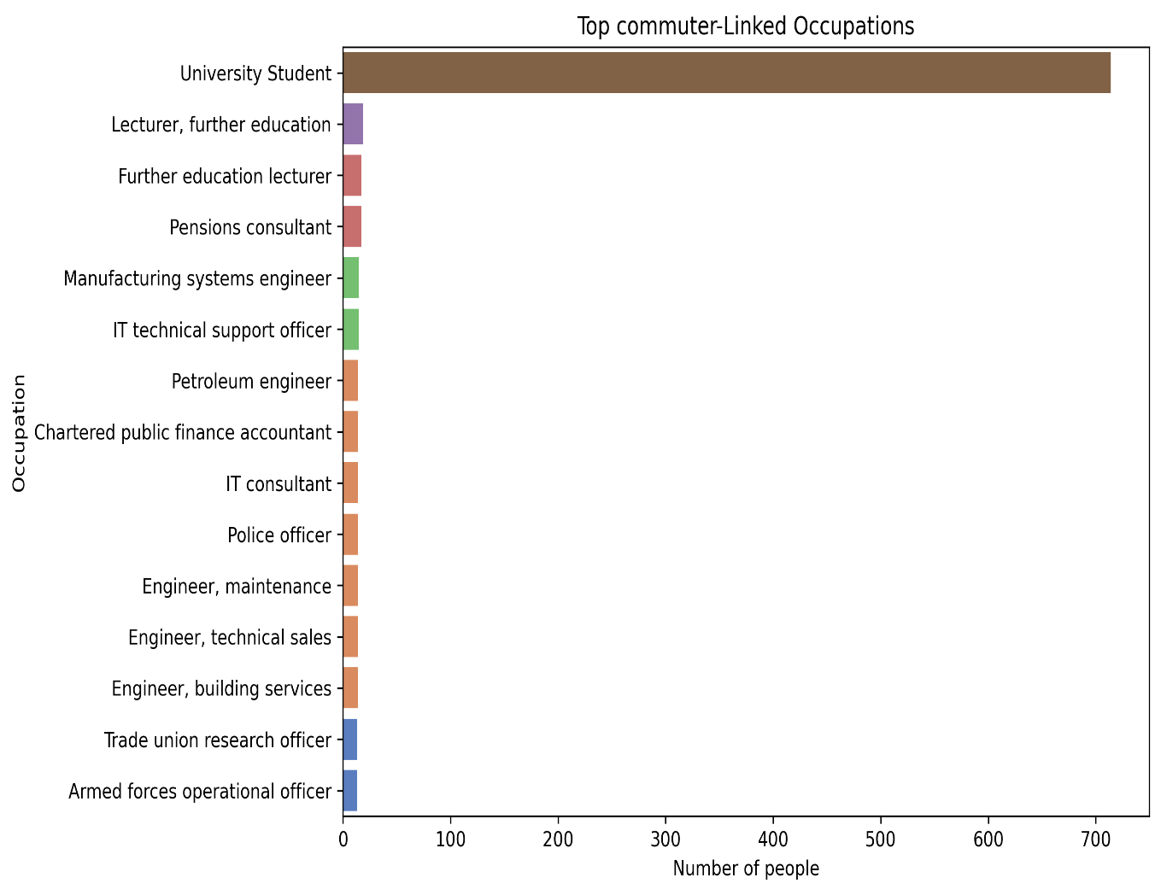
Figure 1. Distribution of commuting occupations based on refined criteria

- Religoius Representation
Religoius affiliation is heavily skewed toward Christain denominations:
Table 2. Religoius affiliation
Religion | Count
Unknown | 6162
Christain | 2300
Catholic | 1144
Muslim | 146
Sikh | 60
Jewish | 45

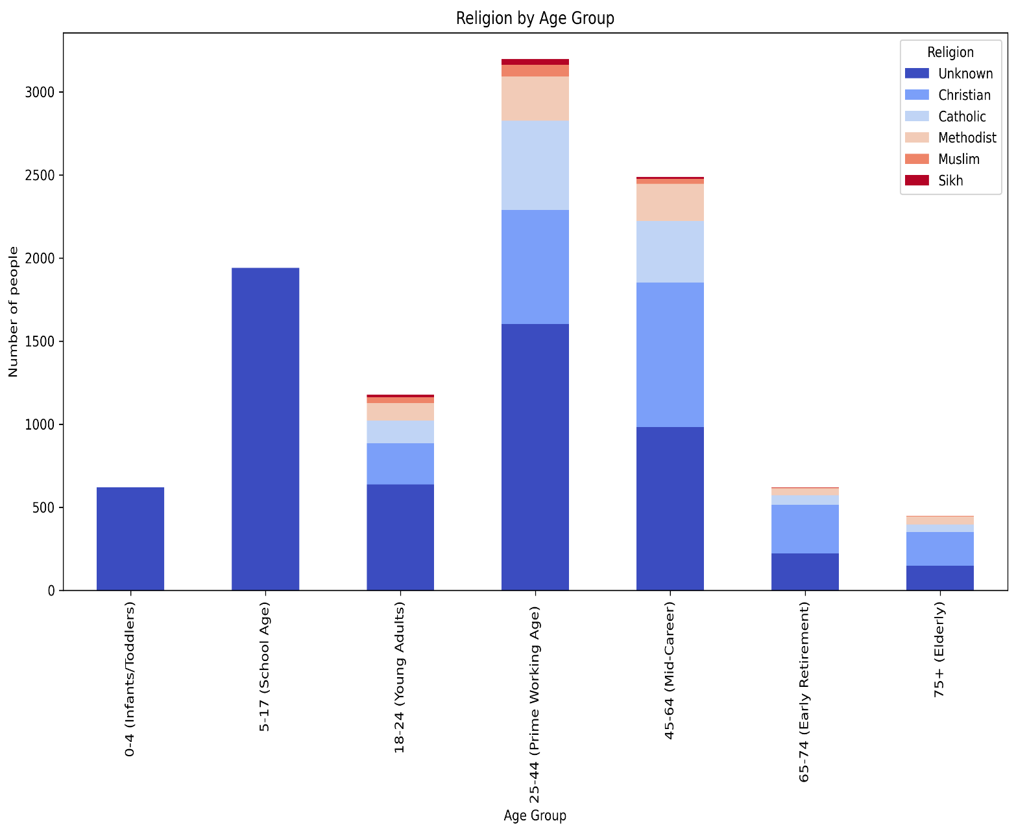
Figure 2. Bar plot showing Religoius Affiliation Distirbution

- Household Structure and Population Turnover
- Average household size was approxiamately 3 person
- 622 children were aged 0-4, sugessting stable birth trends
- 451 residents were 75+, implying moderate elderly care needs

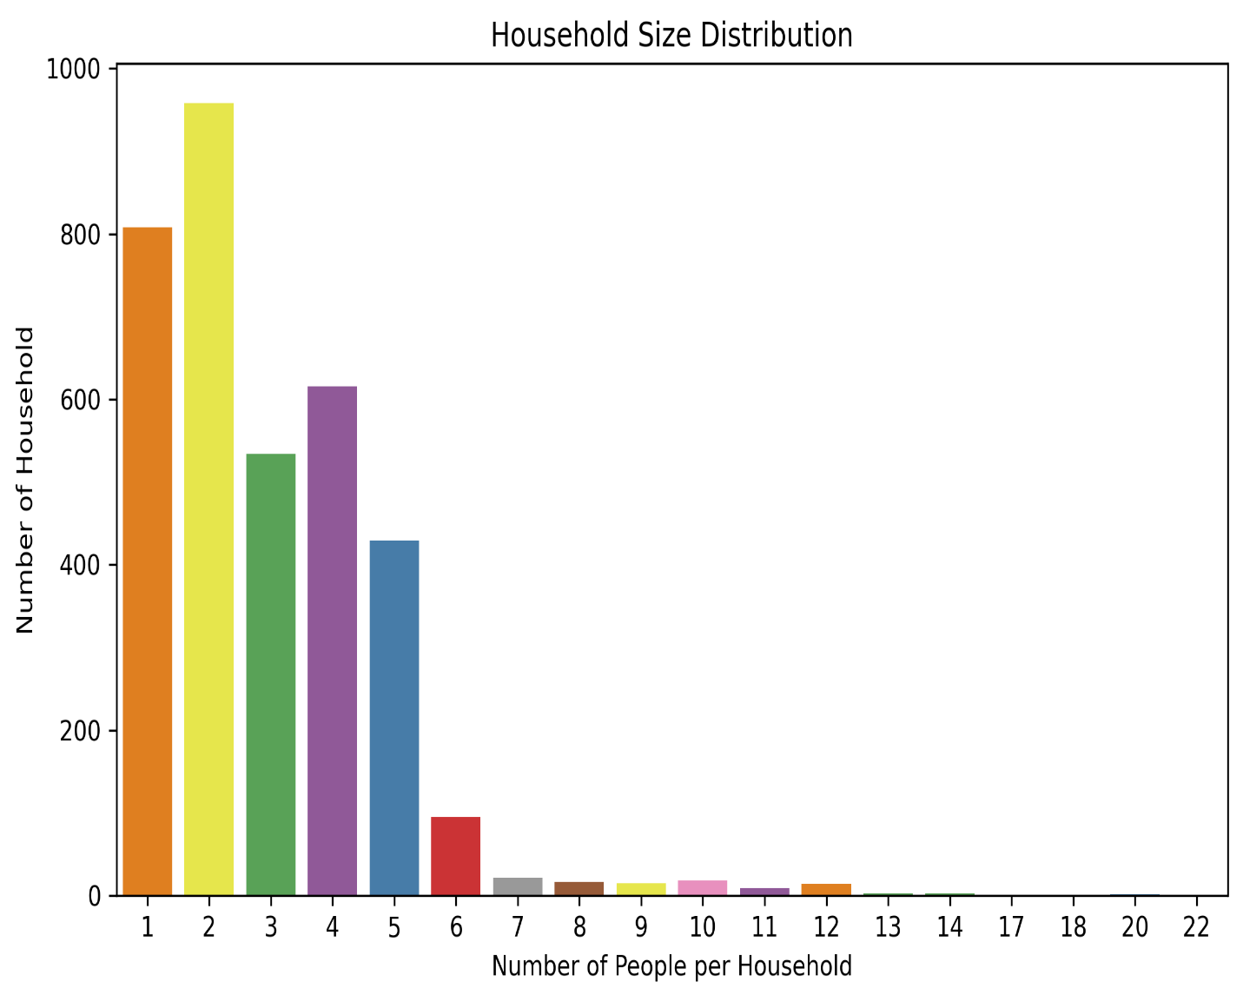
Figure 3. Bar plot showing Household Distribution

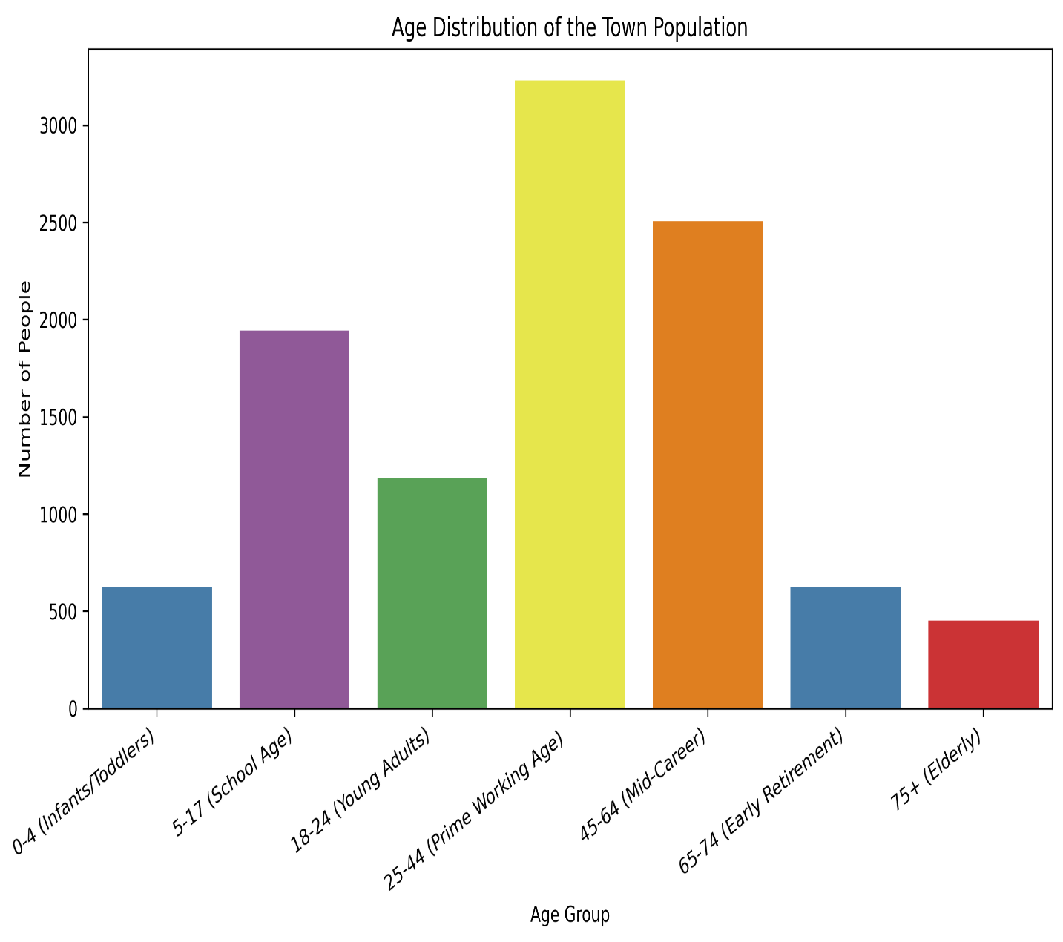
Figure 4. Bar plot showing Age Distribution

- Medical Needs and Reproductive Demorgraphics

- Only 80 individuals were recorded with an infirmity which is about just 0.8% of the dataset. However, this data is unreliable due to 99.2% being marked as “Unknown”
- There are 2411, females aged 18 – 44 making 23% of the total population

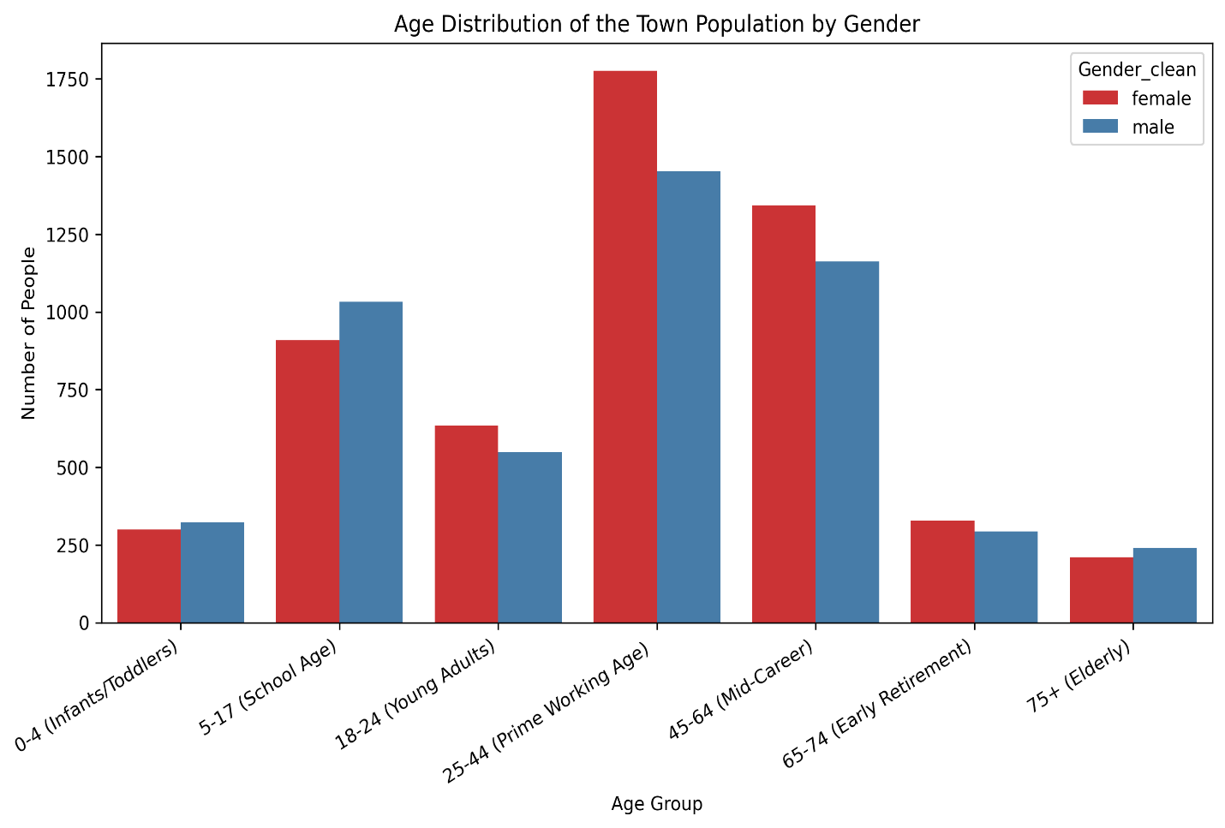
Figure 5. Bar plot showing Age Distribution of the Town population by Gender

- Marital Status Analysis
Table 3. Marital Status Distribution
Marital Status | Count | Percentage
Single | 6221 | 58.94%
Married | 2968 | 28.12%
Divorced | 979 | 9.28%
Widowed | 386 | 3.66%

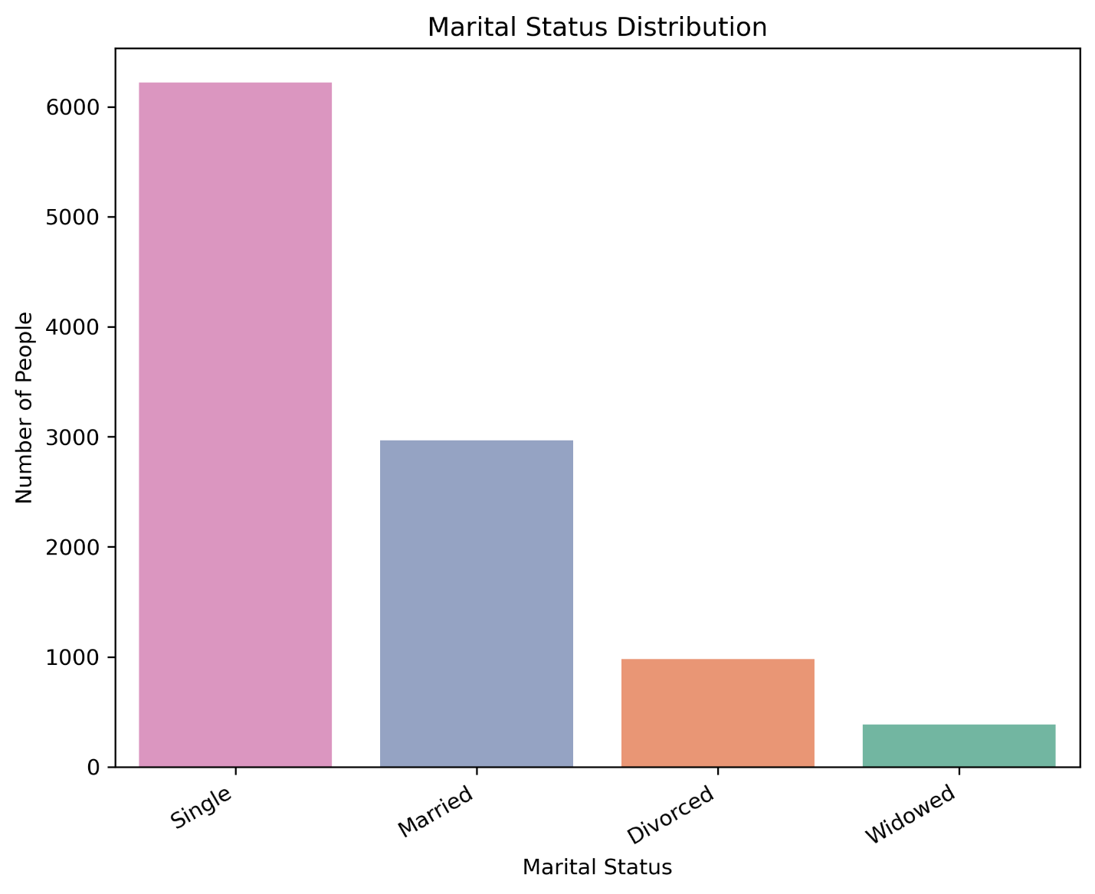
Figure 6. Marital Status Distribution

B. Investment Recommendation: Employment and Training
B.1. Youth Unemployment
Table 3. Unemployment Rate by Age Group
Age Group | Unemployment Rate
25 – 44 ( Prime Working Age ) | 351
45-64 ( Mid Career ) | 238
65-74 ( Early Retirement ) | 34
75+ ( Elderly ) | 21
0-17 ( Minors ) | 0

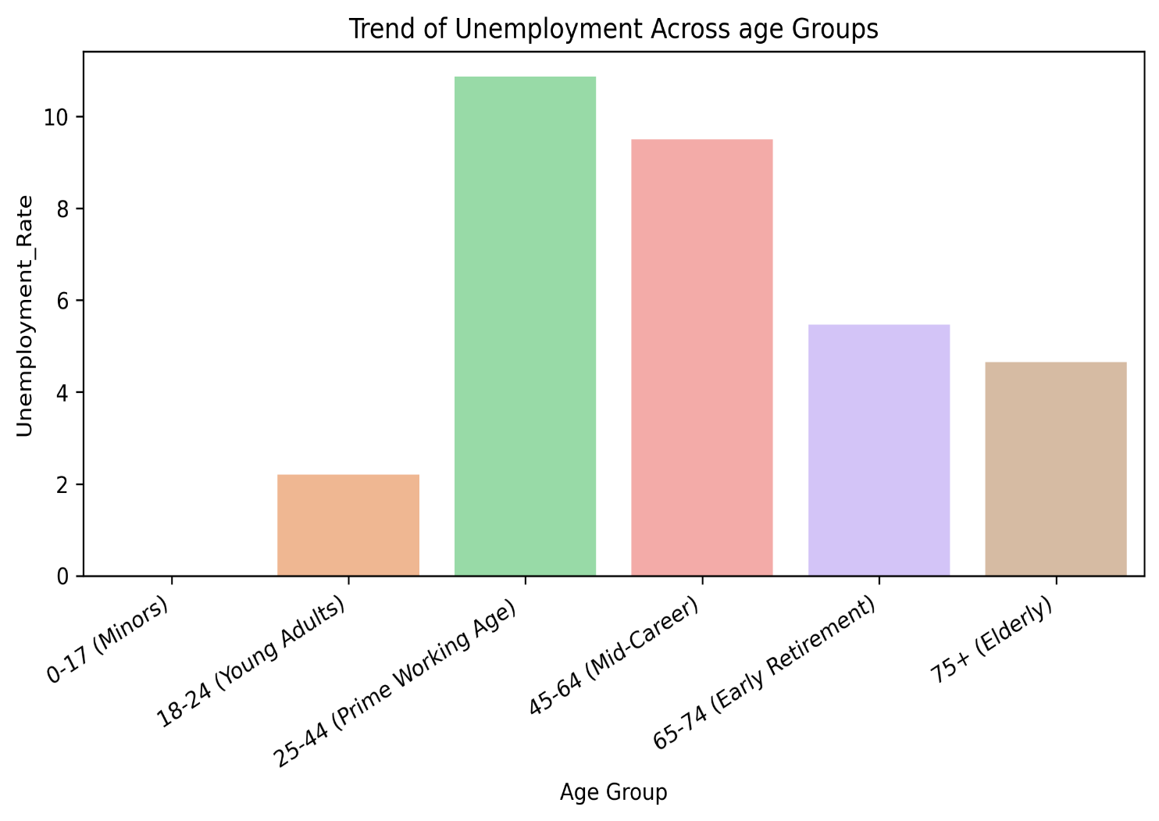
Figure 7. Unemployment rate by age group
A line graph shows peak unemployment for individuals aged 25-44, suggesting challenges with entry into the workforce

.

Discussion
In this section, I walk throgh key insights from the data and explain why specific development projects are best suited for the town’s future. These recomedations are suported by our analysis of occupation, age group distribution, and other demographic factors—and are discussed in relation to findings from external research where relevant.
- What Should Be Built on the Unoccupied Plot of Land?
Based on the full dataset, the most sensible development is a train station. Why? The census shows that nearly 30% of the town’s population are commuters. This includes 3,115 students and a significant number of professional such as lecturers, engineers, consoltants, and other skilled workers. These individuals are primarily concentrated in the 18 -24 and 25-44 age groups—key indicators of daily travel needs for education and employment.

The reviewed occupation-by-age data supports this conclusion:

- The 18-24 group includes 714 university students, showing high demand for access to tertiary education institutions.

- The 25-44 age group has 351 unemployed residents, but also includes skilled professionals like lecturers, surveyors, and consultants. This suggests that a substantial portion of this group likely comutes for work.

A train station would:
- Alleviate traffic congestion by reducing car dependency.
- Support students and workers with affordable, reliable transit options
- Encourages a shift to sustainable transportation, reducing carbon emissions
These findings aling with research by (Maharani, 2025), who found that access to public transport significant boosts employment accessibility. Similarly, (Banister,D. Giovani, M., 2010), highlights the role of transport infrasture in regional development, noting its potential to expand job access and economic inclusion. Also (Green, Anne E., Sissons, Paul, Broughton, Kevin, De Hoyos, Maria, Warhurst, Christopher and Barnes, Sally-Anne, 2015) pointed out that a factor to connect people to jobs is linked to the avaliability, afforability and access to transport. All these suppoort the option to build a train station.

Other options were considered but are not priorities:
- High-density housing isn’t currently needed. The average household size is around 3 people, and there there’s no indication of overcrowding.
- Low-density housing does not match the town’s socioeconomic profile. There is limited evidence of a large affluent population seeking expansive homes.
- Religoius buildings: Although 2,300 are Christain and 1,144 Catholic , over 6,000 residents listed ‘Unknown’ for religion. Without clearer insight into religoius diversity or nedd, asecond place of worship is not well supported.
- Emergency medical centre: Although 2,411 women are of reproductive age, only 80 residents were identified as having infirmities, which is too limited to justify a dedicated urgent care facility
- Marital status: With 58.94% of the population being single and 28.12% married, there is no strong pattern of family expansion that would justify prioritising maternal services or housing over transportation needs.

- Which Area Should Receive Investment?
The clearest investment priority is employment and training programs. The data shows that 670 residents are unemployed, with the highest unemployment rate in the 25-44 age group which is the prime working age. This suggest significant untapped human capital in a group that stands to benefit from upskilling or reskilling.
Considering the town’s commuter-heavy profile, training initiatives could also:
- Prepare residents for remote or hybrid job opportunities
- Support local entrepreneurship and employment schemes.
- Reduce economic depenndency on larger cities.
These recommendations align with findings by (Outlook, 2021) suggests that towns with localised upskilling initiatives tend to experience faster recovery in employment post-disruption(e.g. pandemic or industry collaspe).
Other investment areas were considered:
- Old age care: only 451 residents (4.3% ) are aged 75+ , and aged 65+,suggesting elderly care is a future but not immediate concern.
- Education: While 622 children are aged 0-4, indicating stable birth rates, this has not yet translated into demand for expanded schooling infrastructure.
- General infrastructure: Upgrades may be required as the towns, but at present, the data not indicate an urgent need.
Significance and Future Implications
The findings of this analysis highlights the importance of data-driven planning. The commuter nature of the population indicates that accessible transport is not just a convenience but a necessity. Similarly, the high unemployment in the prime working-age group points to the need for targeted investment in human capital.
In the future, the town may need to revisit:
- Healthcare infrastructure, especially if the elderly population increases.
- Housing needs, particularly if there is population growth or a sight in family dynamics.
- Educational infrastructure, as the current young child population ages
Monitoring these trends will help local authorities stay ahead of demand, ensuring sustainable and responsive development.

Conclusion
This study used census and occupational data to evaluate development options for a commuter town. Based on analysis of commuting patterns, employment status, age group distribution, and professional roles, two recommendations emerge clearly:
- Build a train station to serve the commuter population and reduce car dependency. This is justified by the town’s heavy student and working commuter base.
- Invest in employment and training programs for the 25-44 age group to address unemployment and enhance skill development.
These findings are consistent with literature that supports infrastructure improvements (R. C. Ewing, Shima Hamidi, James B. Grace, Y. Wei, 2016) .
While other options like medical facilities or expanded housing may be justified in future, they are not immediately necessary based on the town’s current demographics and occupational profile.

References
Baffour, Benard, King, Thomas, Valente, Paolo, 2013. The Modern Census: Evolution, Examples and Evaluation. International Statistical Review, December, III(81), pp. 407-425.
Banister,D. Giovani, M., 2010. Integrated Transport: From policy to Pratice: London.
Green, Anne E., Sissons, Paul, Broughton, Kevin, De Hoyos, Maria, Warhurst, Christopher and Barnes, Sally-Anne, 2015. How cities can connect people in poverty with jobs., York: Joseph Rowntree Foundation.
Maharani, N., 2025. Effect of Public Transportation Accessibility on Employment Rates in Indonesia. INterantional Journal of Sociology, 4 January, 9(1), pp. 1 -13.
Outlook, O. E., 2021. Navigating the COVID-19 Crisis and Recovery, Paris: OECD.
R. C. Ewing, Shima Hamidi, James B. Grace, Y. Wei, 2016. Does urban sprawl hold down upward mobility?. Landscape and Urban Planning, Volume 148, pp. 80-88.
Skinner, C., 2018. Issues and Challenges in Census Taking. Annual Review of Statistics and Its Application, I(5), pp. 49-63.

